Name: Pranali Sonawane
Subject: CCNA
Lab – Backup-config :
First, we have taken one Routers and one server . The Router are connected to the server using Crossover cables.
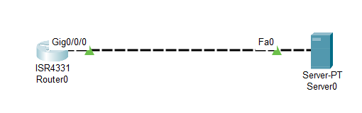
Open Router 0 – CLI prompt then type following commands
Router>enable
Router#configure terminal
Router(config)# hostname ccna
ccna(config)# interface gig 0/0/0
ccna(config-if)# ip address 10.0.0.1 255.0.0.0
ccna(config-if)#no shutdown
ccna(config-if)#exit
ccna(config)#exit
ccna# exit
ccna# copy running-config startup-config
Destination filename [startup-config]?
Building configuration...
[OK]
ccna# copy startup-config tftp
Address or name of remote host []? 10.0.0.2
Destination filename [router-config]? new-router
Writing startup-config...!!
195 bytes copied in 6.2 secs (32 bytes/sec)
ccna# erase startup-config
Erasing the nvram filesystem will remove all configuration files! Continue? [confirm]
[OK]
Erase of nvram: complete
ccna# reload
Proceed with reload? [confirm]
Open server 0 –
  - IPv4 Address: 10.0.0.2
  - Subnet Mask: 255.0.0.0
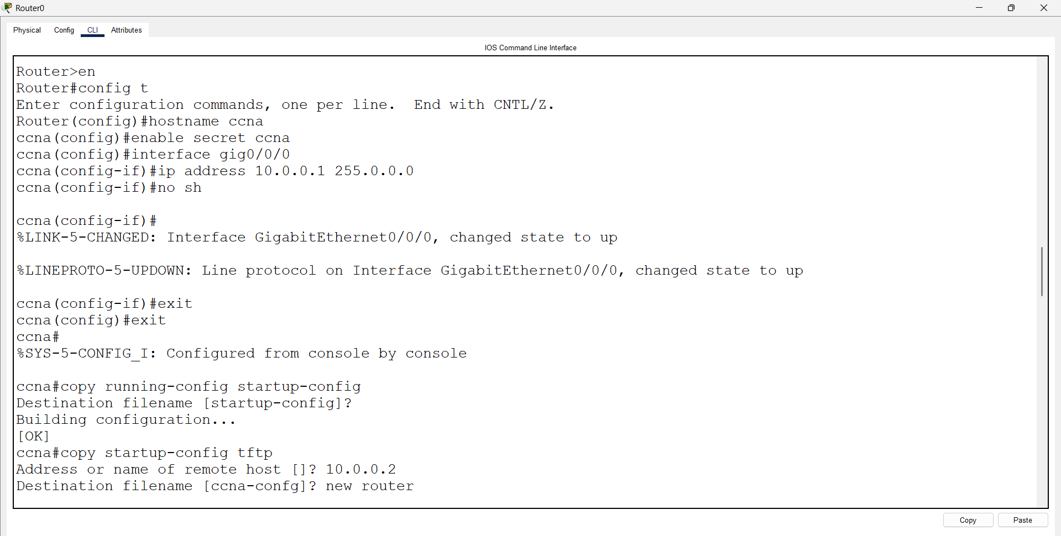
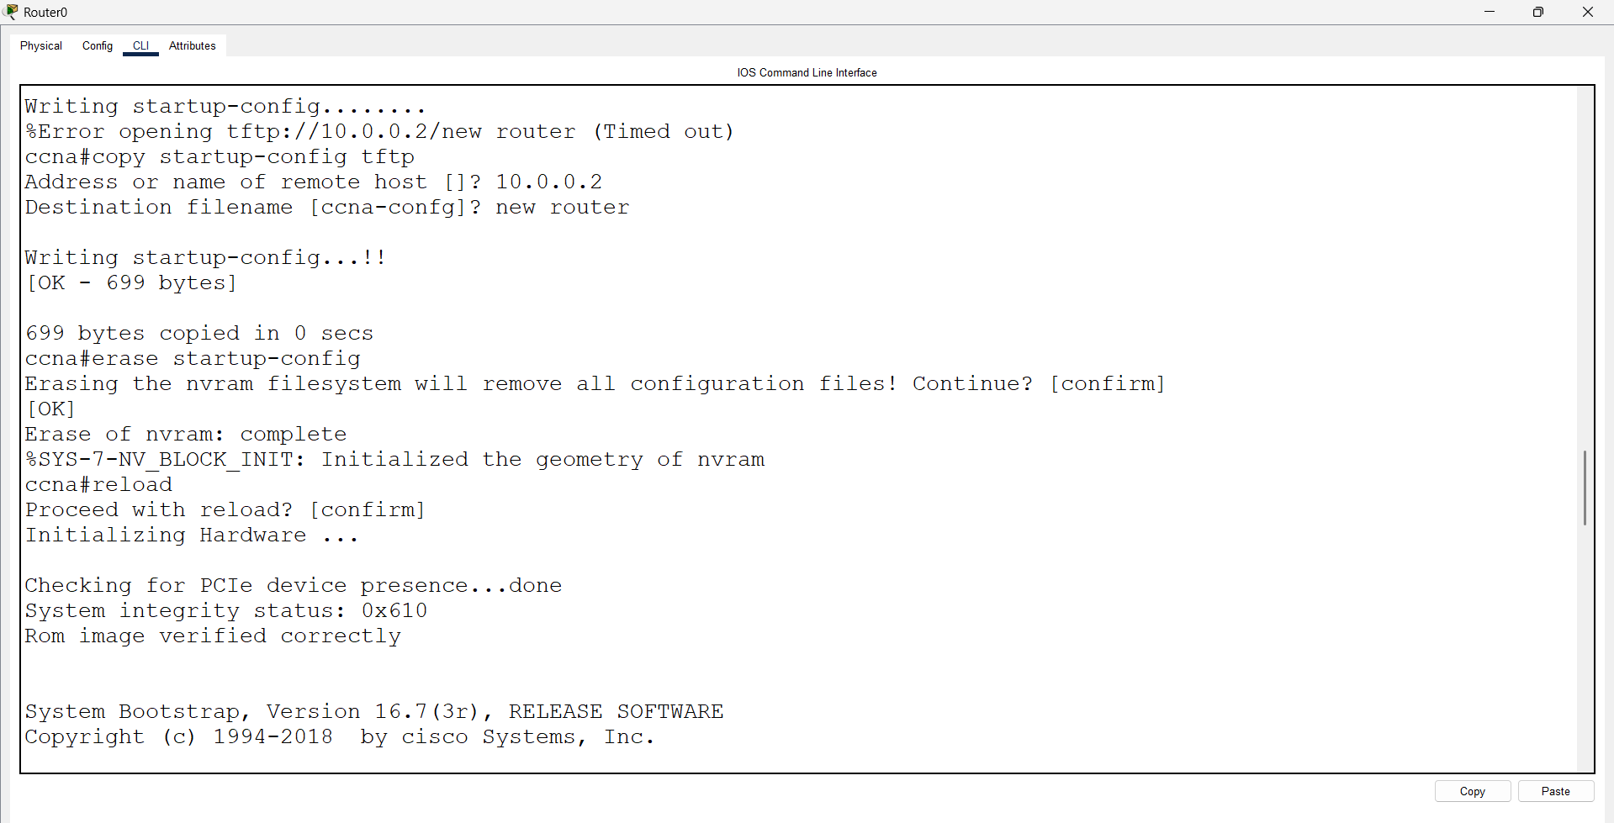
After go the Server0 ---- services ---- TFTP ----new router is present.
Next : Router 0 is deleted and add the new Router 1.
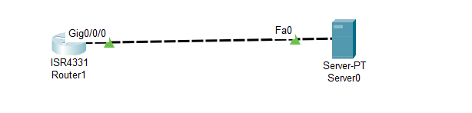
Router>enable
Router#configure terminal
Router(config)# interface gig 0/0/0
Router(config-if)# ip address 10.0.0.5 255.0.0.0
Router(config-if)#no shutdown
Router(config-if)#exit
Router(config)#exit
Router# exit
Router# copy tftp: startup-config
Address or name of remote host []? 10.0.0.2
Source filename []? new-router
Destination filename [startup-config]?
Loading tftp://10.0.0.2/new-router
Loading new-router from 10.0.0.2: !
[OK - 699 bytes]
699 bytes copied in 3.000 secs (232 bytes/sec)
Router# copy startup-config running-config
Destination filename [running-config]?
1917 bytes copied in 0.416 secs (4606 bytes/sec)
ccna#
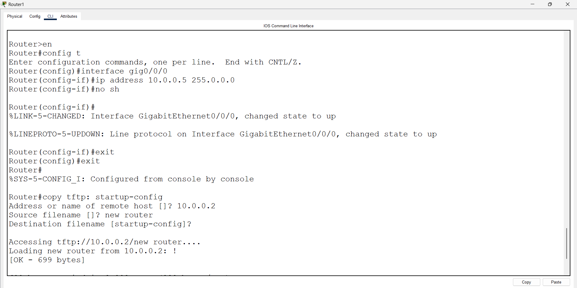
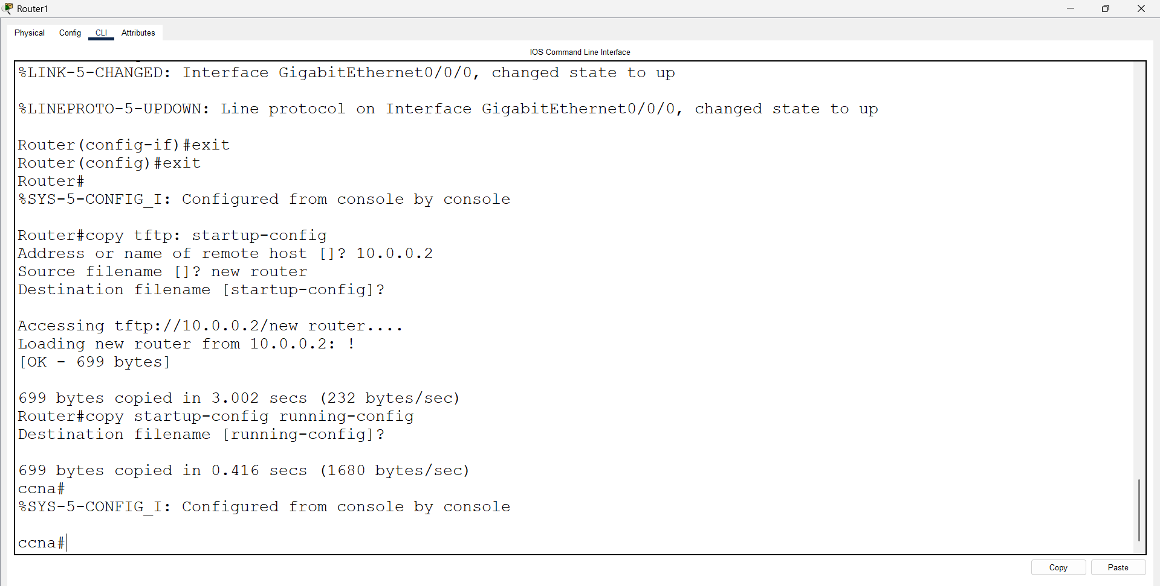

Password Recovery
In the same setup, use a backup configuration to perform password recovery.
